**OUTPUTS FOR CAMERA RENTAL APPLICATION**

* **Login and adding the camera record in the list**

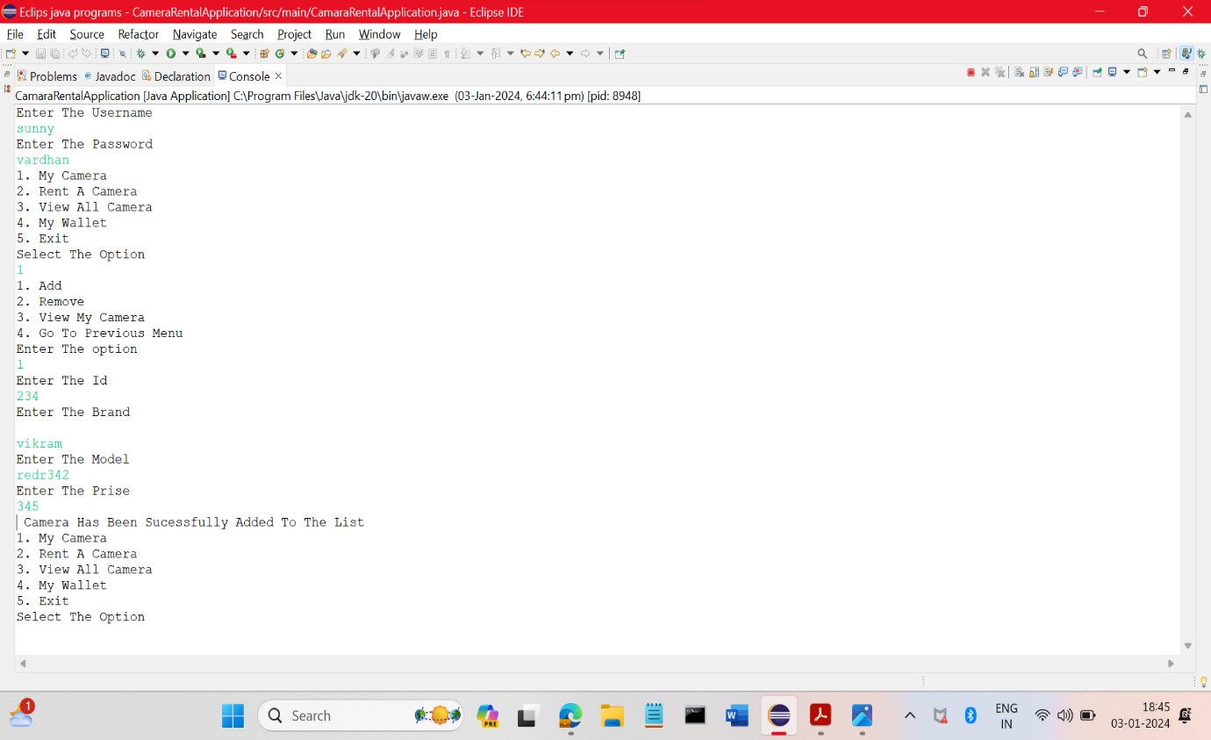

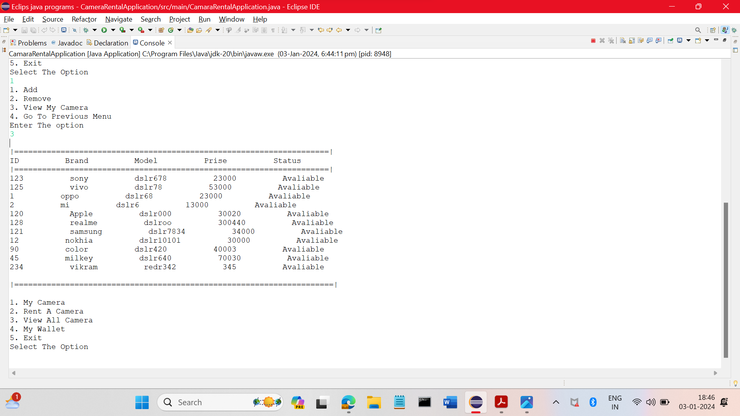

* **Removing Camera record from the list**

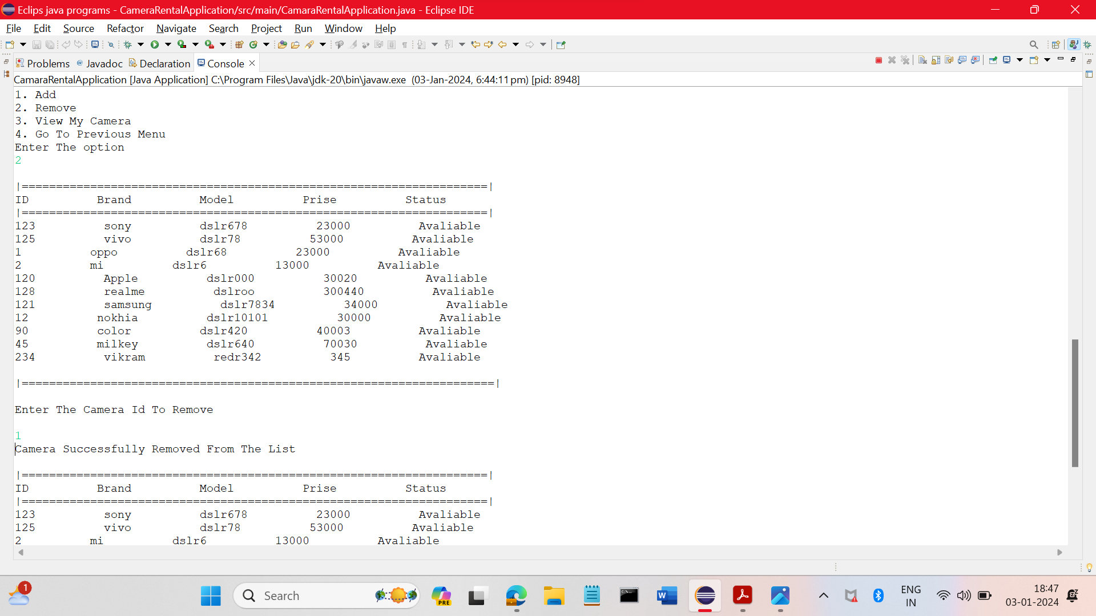

* **Taking Rent**

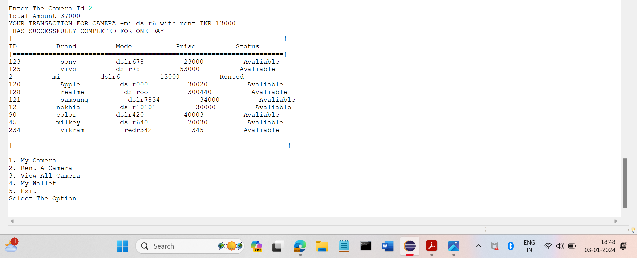

* **Viewing the camera list**

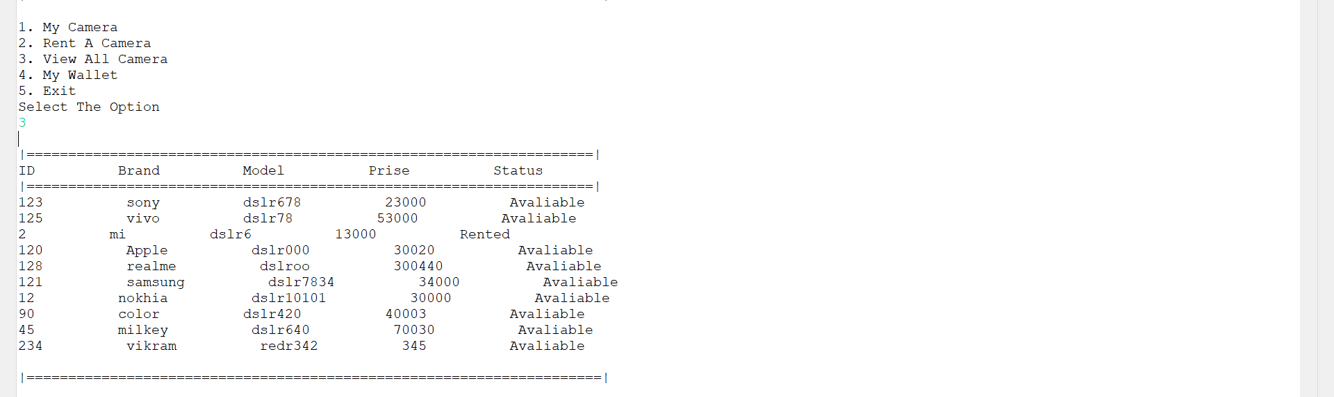

* **Checking and adding the balance**

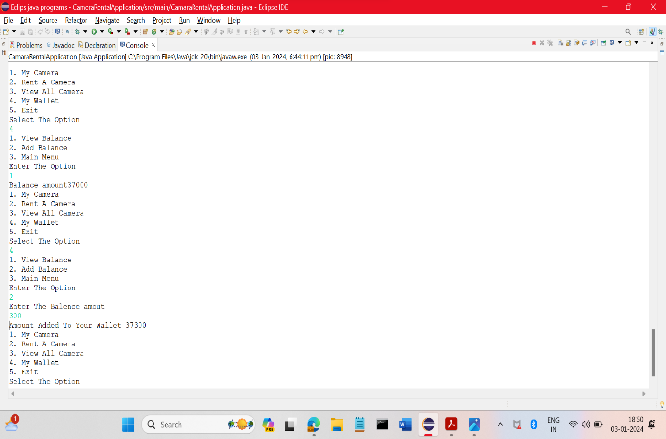

* **If the balance is in sufficient it will handle the Exception**

